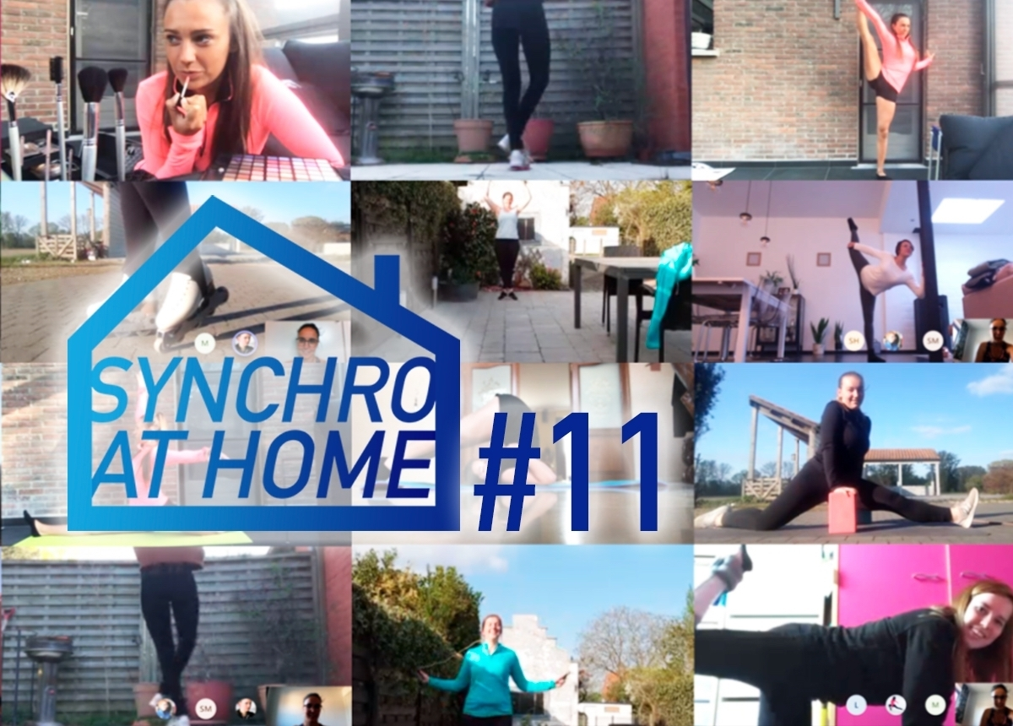
Skaters from Team Crystallice from Belgium continue to stay in touch and practice together... virtually.
In this very special time, synchro teams around the world are trying to find new alternatives to continue training together. Let's go to Belgium, where the skaters of Team Crystallice (Mixed Age) in Ghent have a lot of great ideas.
Immediately after the announcement of the Belgium lockdown, Mireille Mostaert the head coach of Team Crystallice and four other synchro teams (Juvenile, Basic Novice, Junior D2, and Adult) in Ghent and her assistant Maxime Hanssens, start to think how to keep the skaters active.
"We created a platform for our teams through ‘Microsoft teams’. This makes it possible to share workouts, pictures, challenges, jokes… with each other," explains Mireille Mostaert who can organize video calls with one team or all teams together.
Diversifying the off-ice sessions
"We alternate between yoga, dance routines, flexibility, strength, agility, cardio workouts, technique training and games. Besides, we also use the time to educate them ‘how to do your makeup and hair during competitions’," continues Mireille.
"Every week we are looking for new routines and are grateful when we get help from Jura Synchro. We already experimented with their yoga and fitness courses of Tiina and we were really satisfied. Some of our skaters also participate in the OTM online camp, which is a wonderful initiative for skaters and coaches."

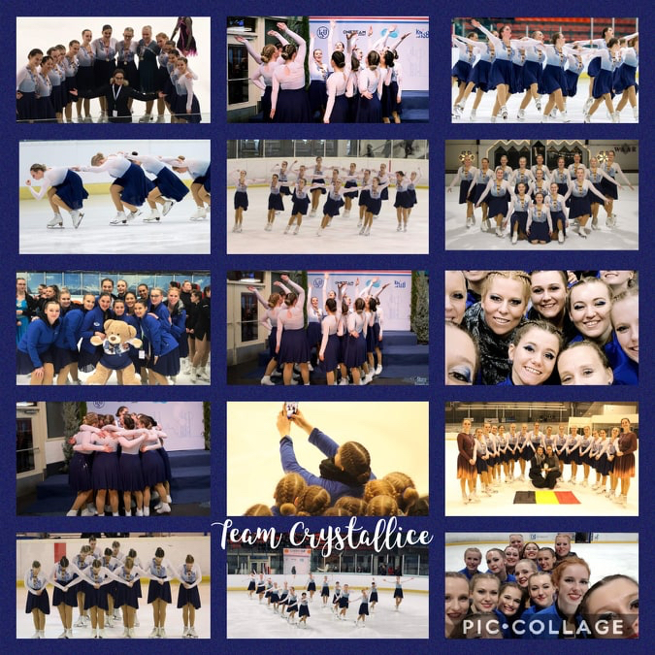

What many experts repeat continuously during this period, the key for success is to keep in touch, stay connected to others, to their synchro team. And Mireille Mostaert figured it out clearly.
"As we use Microsoft teams simultaneously, we can be together, motivate and help each other. We experienced that the skaters need social contact with each other and they want to stay active together. Mostly, after training, we take time to talk virtually with each other about random things and the corona situation and how they deal with it."
Coronavirus: an opportunity to focus on new aspects
"Often during the season, there is not a lot of time to pay attention to the aspects such as strength, flexibility, endurance, coordination and speed of our athletes," notes Mireille Mostaert who is thankful that this kind of software exists to keep connected with the team. The online sessions through Microsoft teams help her to monitor the evolution of their skaters. The only problem is that the software has a limited view of 4 skaters at the same time.

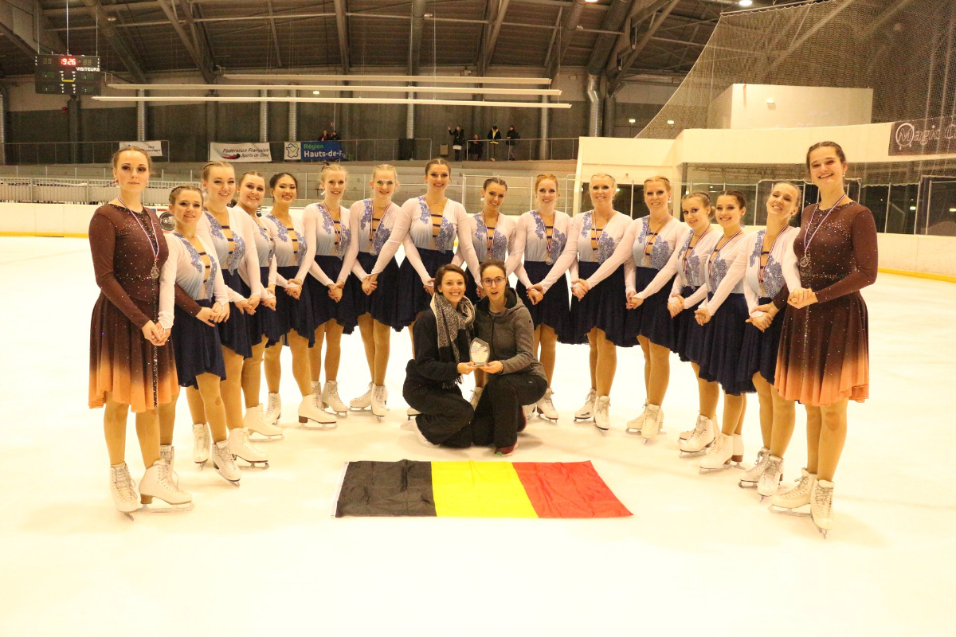

Team Crystallice competes at national and international competitions.

Even if the situation is not always easy to manage, Mireille Mostaert stays positive. "This situation forces us to be creative, to think together, look for alternatives and will make us stronger after all. Also when you don’t have ice, you can be productive and accomplish a lot."But the biggest wish for this coach is to have a normal season. Indeed, she is also in the coaching team of Team Phoenix (Senior ISU). This team should have traveled to Lake Placid to represent Belgium in the Worlds at the beginning of April.
New season, new goals
Last year, Team Crystallice consisted of 18 skaters. Their program was created on the music of the movie ‘Mount Everest’. "It was literally a real “mountain” for us since the program went through a complete transformation during the season. It took some time until we were entirely satisfied with the result and were able to perform it sufficiently. And just when we had reached it, the season was abruptly stopped by the coronavirus," regrets Mireille.

For this Mixed Age team, the main goal for the season 2020-21 will be to improve their technical score, execution, skating skills, but also to grow as a team and present their new program.
"We hope that 2021 will be the year where we can welcome teams from different countries during our first synchro competition called Ice Crystal Trophy (that has been cancelled as all the other events)," says Mireille Mostaert.

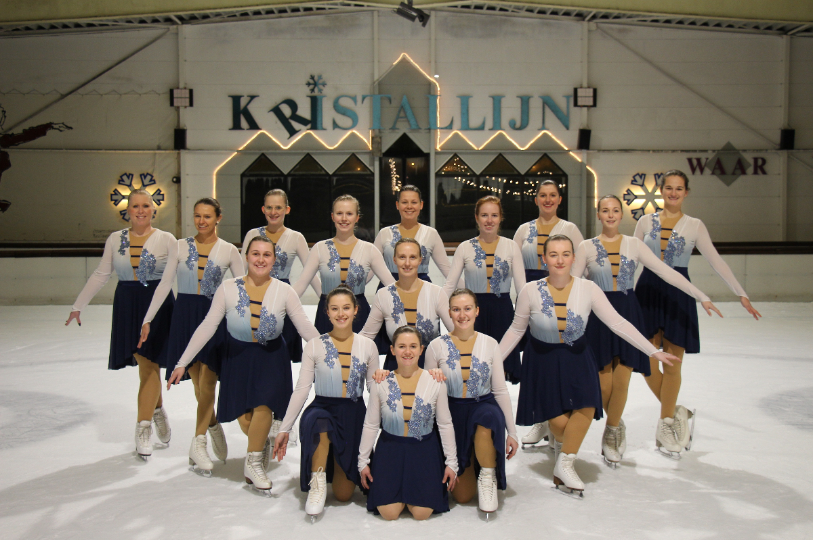

Team Crystallice from Ghent (BEL) is the most experienced team in the club.

